CET 102
THEATRE EQUIPMENT
Operation theatre design
- This is room in the hospital where surgical operations takes place.
- Structural requirements
- Surroundings
- Operation theatre should be situated in a clean environment. It should be at least some meters from the wards, mortuary, labs etc.
- It should be at the upstream of the wind e g all air inlets should never face infections areas.
- All trees and grass around the theatre should be trimmed and maintained in hygienic conditions.

Size
- The size should be adequate to allow surgical staff to move freely without the danger of brushing against each other equipment or walls.
- Trolleys should be able to be pushed around as designed without the possibility of accidents. The recommended minimum size of an operational theatre is 5m by 6.5m.
- Where any heavy cases of operations are required, it is always advisable to build another theatre than making first one too large.
Walls
- Walls should have few corners possible to deny microbes off hiding and breeding places. The few corners should be as smooth as possible to allow thorough cleaning, all the sides should be crack free and impervious. The walls should have at least three layers of coating.

Floors
- Ideally floors should be terrazzo surface or very smooth cement floor. If funds are available floors should be made antistatic. The floor should have a slope 1 to 100 towards the unsterile side to case the washing down storage pipe should be fitted from 150mm above the floor to flood the entire floor when turned on.
Ceiling
- The ceiling should be of soft board or polystyrene and coated with at least three layers of paint to make it impervious.
- At least three metres above the floor.
Windows
- Are expected to have an area of 5m² with the height being 3m above the floor. The cill of the window should be above the floor by 1.6m to allow shelving and provide good spread angle of light into the room.
- The window should also provide good spread angle of light into the room.
- The window should face north and south direction to avoid direct sun and should be shaded by a roof overlapping of at least 800mm. To facilitate ventilation, the window should be fitted with independently adjustable top and bottom is necessary but this should not interfere with good ventilation.
Doors
- Should be kept at minimum because every time a door is opened and closed, there is pumping action that draws dust from the floor into the room.
- Again doors’ frames, handles, locks and hinges may harbor more germs. All other openings other than windows and doors should have micro filters to keep off dust and to promote sterility.

Furniture
- Fixed furniture’s should be avoided in favor of mobile ones, where fixed shelves are needed, they must be fitted 50mm from the walls.
- Plastic laminated surfaces should not be used on furniture in tropical climates because they tend to delaminate. Smooth timber finish or chip-board with good paint finish about 4 layers should be used.

Sink
- Sinks should be made of ceramic ware, although stainless steel sinks have a good surface, they are manufactured with many corners which cannot be cleaned well.

Supplies in theatre
- Electrical supply
- Water supply
- Medical gas
Electrical supply
Irrespective of financial condition of the hospital, at least three electrical supplies should be provided:
- Mains supply
- Stand by generation
- Battery supply
- Others e.g solar energy.
All these electrical supplies should be matched or suitable for the anesthetic agent used and calls for high safety requirements e.g use of anti-static sockets 0r switches.

Water supply
- A surgical department should always be supplied with water reservoir, there should be an emergency water supply.
Medical Gases
- There are number of unlimited gas supplies, depending on the capacity and type of surgical operations to be carried on in theatre, it should have at least three medical supplies mainly:
- Oxygen O₂
- Nitrous oxide- N₂O
- Vacuum
- The terminal out of all these gases should be room- interchangeable and should be of quick use and release mechanism.
- All other necessary gases besides the three can be provided externally in cylinders.

THEATRE TABLE
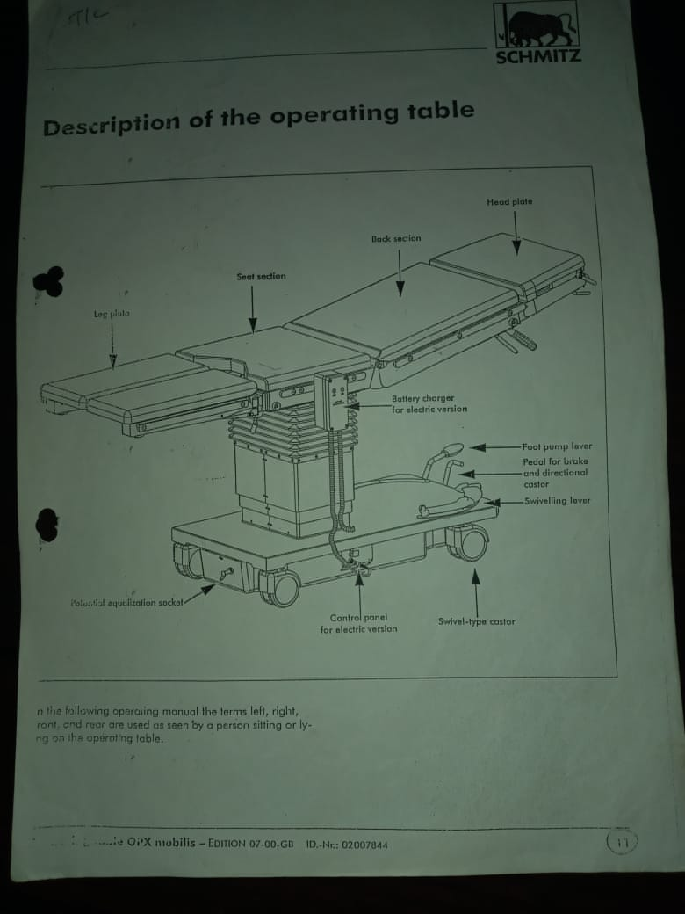

Operation theatre table
- An operation theatre table is a very useful equipment in that besides the main purpose of containing a patient during an operation. It can be used as a trolley to transport a patient to the theatre department.
- It is also used to suit different surgeon’s height and various operation positions

Functions or need for theatre operating table.
- To support or accommodate patients comfortably.
- Facilitate easy and comfortable working positions for various patient postures and heights
- Provision of auxiliary attachments.
- Provision of bulky assembly for radiographic.
Theatre table movement
- Up-down movements.
- Side-ways tilt
- Forward and backward tilt.

Types of operating theatre table
- Different types of operating theatre tables are determined by their various mechanisms causing the movements. According these drives mechanisms principle these operation tables can be categorized into four types:
- Pure-mechanical operation table
- Hydro-mechanical operation table
- Hydro-electrical operating table
- Electrical operation table
Definition to terminologies

Hydraulic
Fluid power systems
- It is utilization of liquids such as oil, water and gas as a media for transmission of energy.

Fluid power systems may be used in the following:
- Carry out mechanical work. It includes application such as shifting, positioning, drilling, turning and milling.
- Controlling applications
- Measurement of process parameter.
Hydraulic system – is a liquid based solutions such as oil, is used under pressure to carry out work.

Hydraulic actuator – consists of a movable position connected directly to the output shaft. The fluid is pumped into a pipe M or N to move the piston up and down.

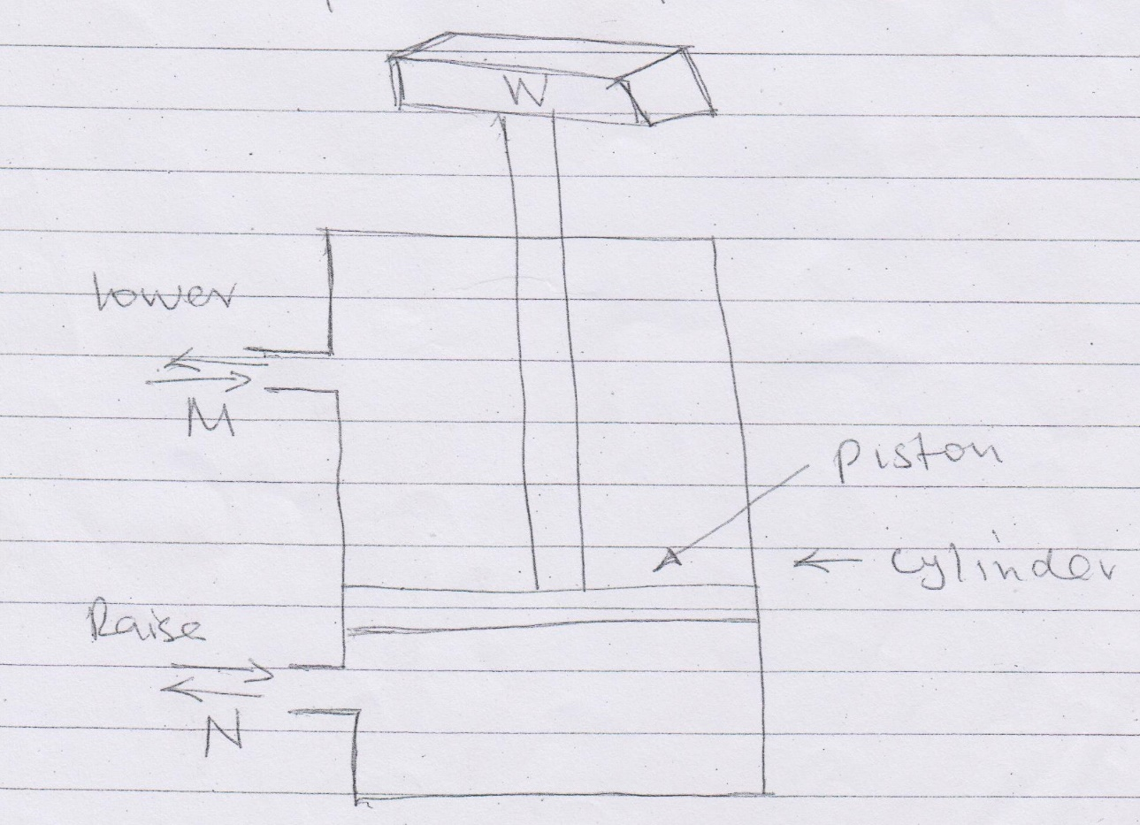

Pneumatic systems – system using gas for powder transmission are called pneumatic systems. When air is compressed and stored, it can be used as a medium for carrying out mechanical work, measurements and for controlling and operating equipment and machines.
Pneumatic systems consists of:
- Motor driven compression
- Directional control valve
- Air receivers
- Pneumatic cylinders.

Single acting cylinder
- It is a simplest type of linear actuator. The fluid is applied on one side of the piston.
- Therefore cylinder can produce work on one direction, the other side of the piston to the atmosphere.
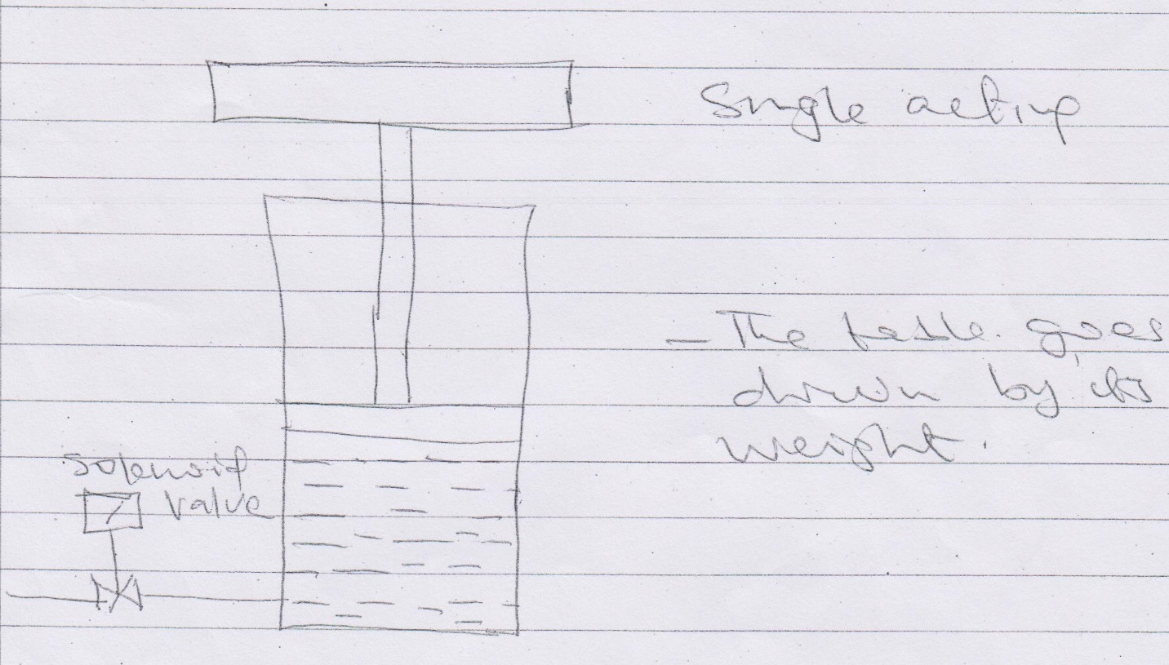

Double acting cylinder
- The fluid pressure is used to extend and retract the piston. The construction of double acting do not have any returning spring. The two points alternately one for supply and the other for exhaust. The cylinder is able to carry out on once in both directions.

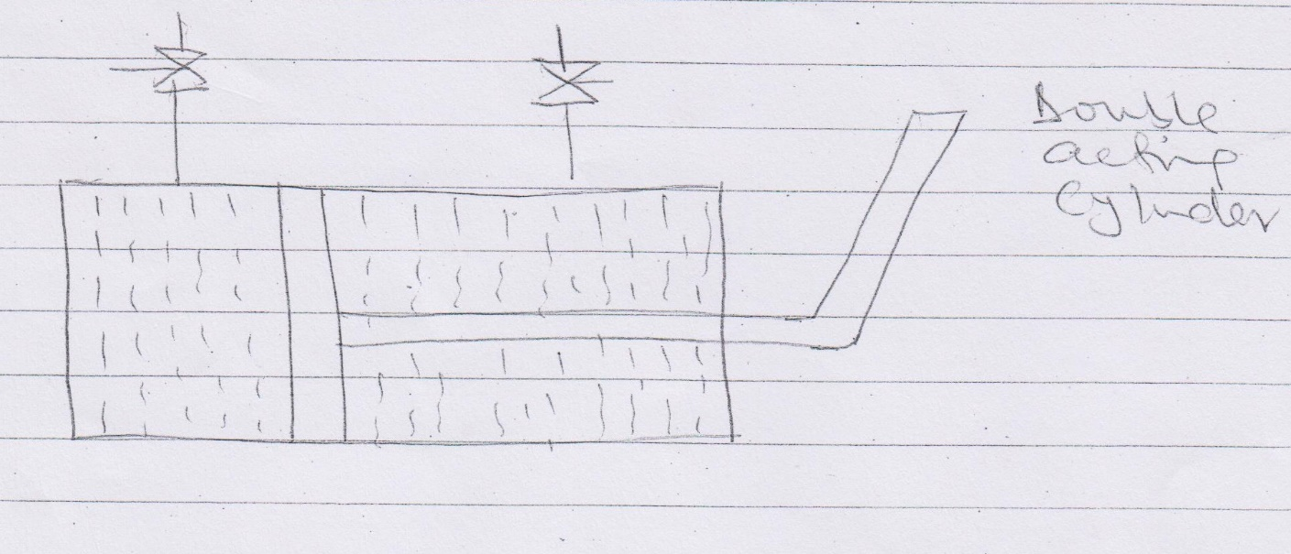

Directional valve
- Found in double acting cylinder where the flow of pressure liquid is directed alternately to the front or back of the piston.

Check valves
- Ensures fluids flow in one direction.

NOTE:
Read and write notes on the characteristics of hydraulic oil.

Mechanical acting systems
- They are referred to as mechanisms, they are essentially used for converting motion from one form to another.
- Various mechanical elements used in mechanisms are;
- Gears
- Linkages
- Cams
- Rack and pinion
- Chains
- Belt drives
- Bearings
Pressure – is defined as a force acting per unit area, exerted by liquid or gas on a surface. The unit of pressure is N/M² or Pa
Pressure measurement is generally made with respect to some reference pressure.
- Atmospheric pressure is commonly used as reference.
- Difference between measured pressure and atmospheric pressure is called gauge pressure.
- The pressure less than atmospheric pressure is called vacuum pressure.
- A pressure of zero is called perfect vacuum
- The different between measured pressure and atmospheric pressure is called absolute pressure.

Type of operation theatre table
- Different types of operation theatre tables are determined by their various mechanisms causing the movements. According to these drive mechanisms, principles, those operation tables can be categorized into four types:
- Pure-mechanical operation table.
- This is a heavy construction type with the cast iron case. It has the minimum movements and adjustments are manual.
- This type of table is made up of wide range mechanical element such as:
- Lead screw
- Rack and pinion wheel
- Worm wheel
- Ratchet
- Cams
- This mechanical elements are responsible for all the movements.

Advantages | Disadvantages
-Cheap capital investments | -heavy construction
-Robust construction | -long patient preparation
-Universal use | -Unhygienic
-theatre safe | -Noisy
-Low maintenance | -Limited movements
-Easy operation

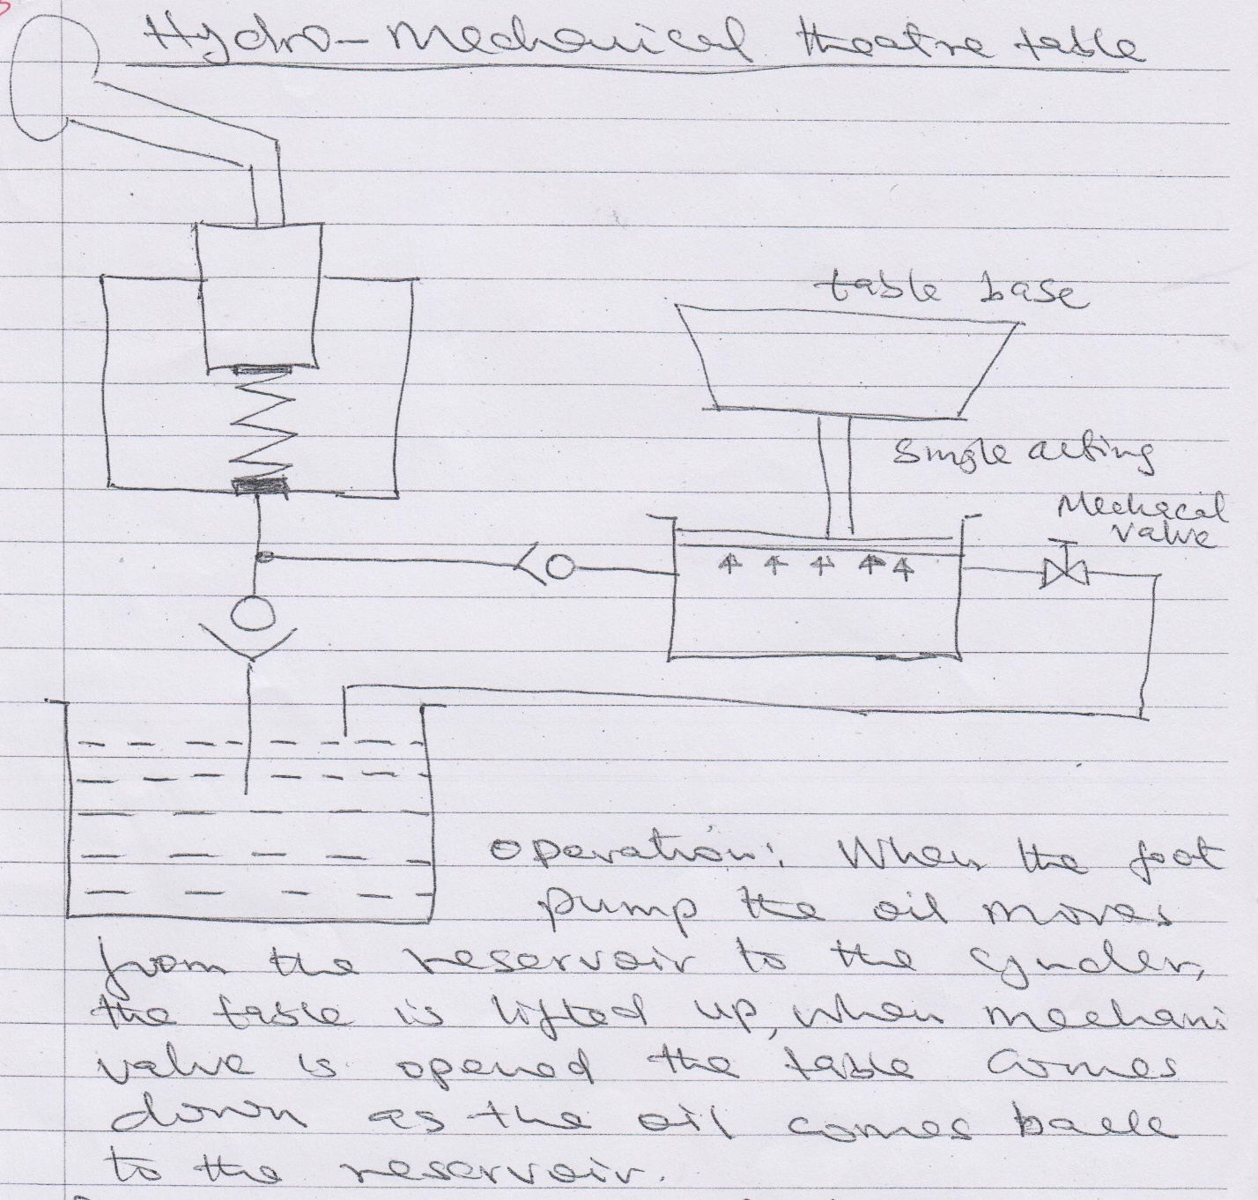
- Hydro-mechanical operation theatre table
- Is improved type of pump mechanical table. The hydraulic components are only for up and down movements, other movements are mechanically operated.

Main hydraulic components are:
- Hydraulic piping system
- Valves
- Manual hydraulic pump
- Mechanical components
Advantages | Disadvantages
-Reasonably cheap | -Heavy construction
-Improved hygienic conditions | Long patient preparation
-universal use | Skilled maintenance labour
Theatre safe/patient safe | Noisy
Easy operation | Limited movement

- Hydro-electrical operated theatre table
- This is improved hydro-mechanical type where the manual hydraulic pun has been replaced by capabilities such as:
- Back rest
- Head rest
- Tandenburg – tilting movement
- To operate these movements safety these hydraulic and electrical components must in cooperate safely elements such as limit switches, micro-switches, current limiters, safety valves and throttle valves.
Advantages | Disadvantages
-various movements | -high capital investment
-light construction | -Delicate equipment
-Short patient preparation time | -Restricted use
-Simple operation | -Theatre unsafe
-Hygienic | -High maintenance cost.
-Very low noise level. | -Skilled operation

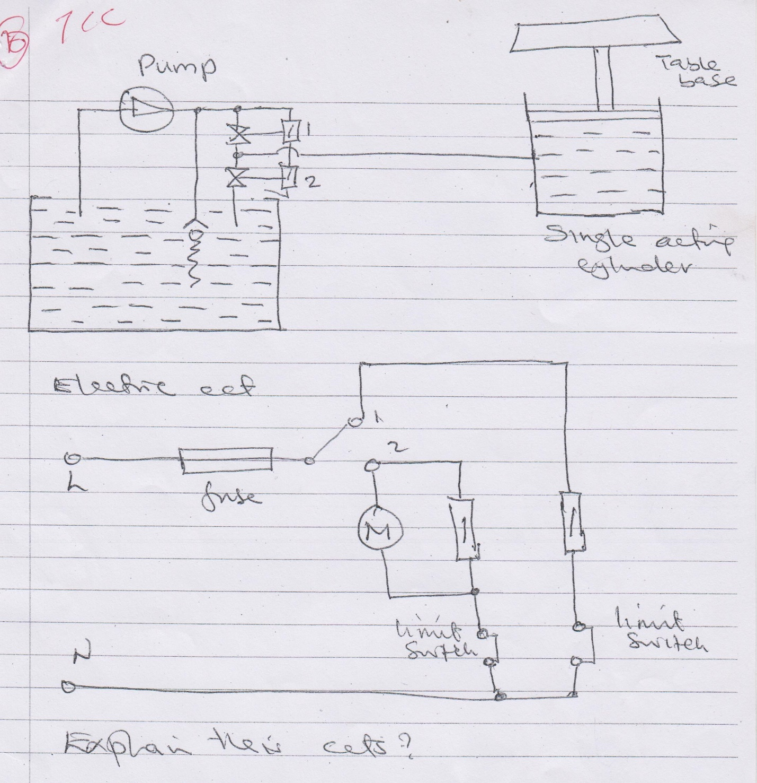

- Electrical operation theatre table
- This is nothing else but a hydro-electrical type whose electrical hydraulic pumps have been replaced by high torque noisy electrical movements.
- A lot of electronics have been integrated into it for control and safety purposes, Pre-programmed positions capabilities.
Advantages | disadvantages
-Unlimited movements | -Highest capital investment
-Light construction | -Most delicate equipment
-Shortest patient preparation time | -Restricted use-AC supply
-Comfortable operation feather touch | -Theatre unsafe
-Hygienic. | -Highest maintenance cost
 | -Skill operation.

QUIZ
- Design a circuit which can move up and down using double acting cylinder, should both piping and electrical circuit.
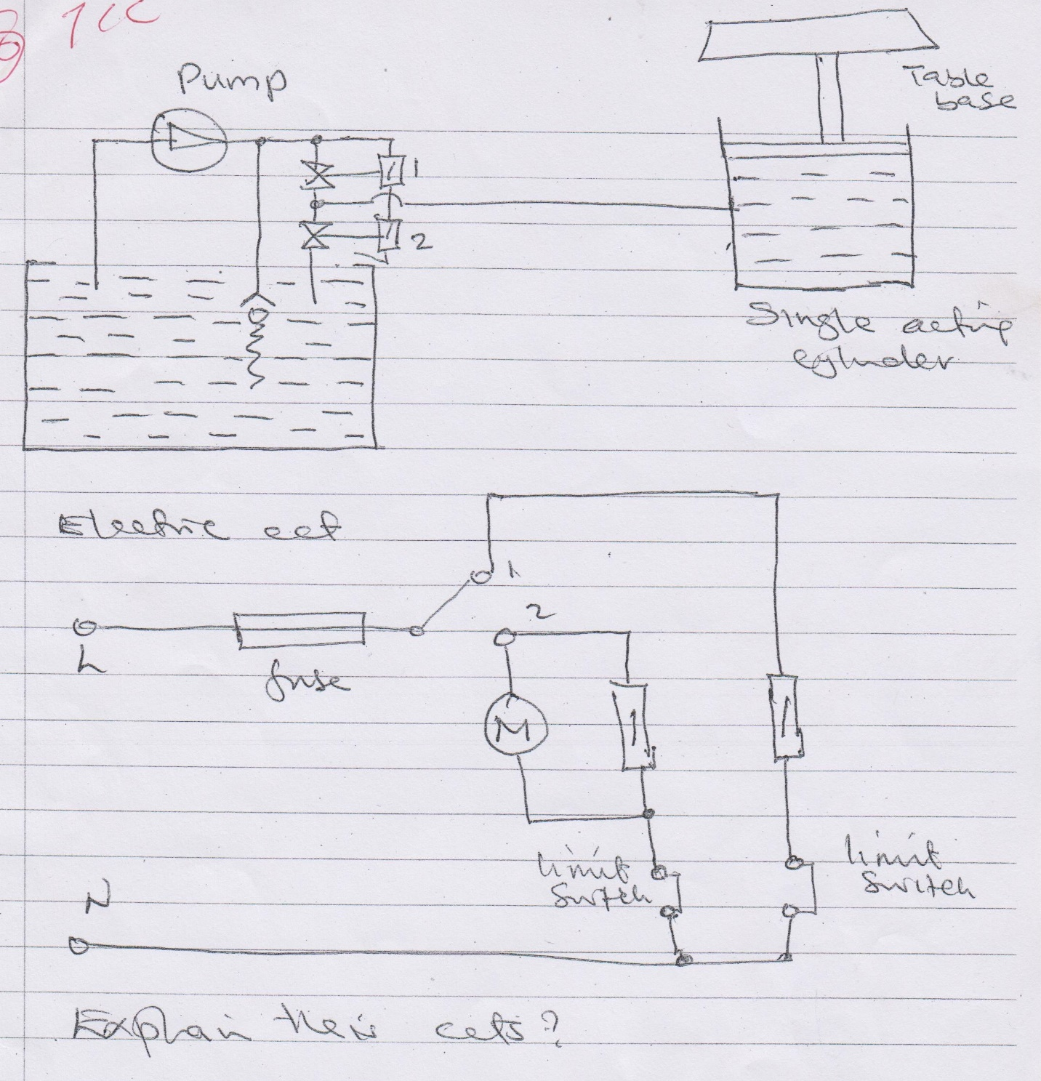

Maintenance done on theatre table
- Replace the old or worn out hydraulic oil
- Clean the reservoir with paraffin or diesel
- Increase the castor wheels
- Repair solenoid valves or replace if faulty.
- Clean the limit switches
- Service the pump
- Check the oil leaks
- Electrical faults/loose current short circuits
- Clean or replace oil filters.

REVISION QUESTIONS

1, Discuss theatre design under following headlines
Structural
Surrounding
2.disscus hygiene precautions in theatre
3.state ten theatre equipment
4.Name and explain 3 types of theatre table
5.disscuss maintenance of theatre table
6, differentiate between hydraulics and pneumatics

